**LIST OF FIGURES**

|  |  |  |  |
| --- | --- | --- | --- |
| **S.N.** | **Figure No.** | **Figure Name** | **Page No.** |
| **1** | **Figure 4.1** | Context Diagram | **10** |
| **2** | **Figure 4.2** | 1-level DFD | **10** |
| **3** | **Figure 4.3** | 2-level DFD | **11** |
| **4** | **Figure 4.4** | Use Case Diagram | **12** |
| **5** | **Figure 5.1** | user login page | **13** |
| **6** | **Figure 5.2** | user registration page | **14** |
| **7** | **Figure 5.3** | home page for user | **15** |
| **8** | **Figure 5.4** | page for all the courses after class 10th | **16** |
| **9** | **Figure 5.5** | page for all the courses after class 12th | **17** |
| **10** | **Figure 5.6** | page for all the courses after Graduation | **17** |
| **11** | **Figure 5.7** | page for some extra courses | **18** |
| **12** | **Figure 5.8** | page for feedback | **18** |
| **13** | **Figure 5.9** | Admin login page | **19** |
| **14** | **Figure 5.10** | Admin dashboard page | **19** |
| **15** | **Figure 5.11** | user manage page | **20** |
| **16** | **Figure 5.12** | course update page | **21** |
| **17** | **Figure 5.13** | course remove page | **22** |
| **18** | **Figure 5.14** | course entry page | **23** |
| **19** | **Figure 5.15** | feedback page for admin | **24** |

ix

**ABSTRACT**

**“Course Guidance System”** is a web-based system. The main aim of the project is to guide students for the best career and courses. The system will help to explore different career and different courses. In the present time, there are many students who belong to very backward area, who don’t have any mentor or guide and don’t know what to study after 10th, 12th or Graduation. Many students take wrong courses, because lack of knowledge and they regret in future. This system will help everyone to choose a best course for their career.

This system will guide students for their best career option. It will help all the students to explore different career and courses, also It will show all the courses available in India so that students can choose their favourite one.

xi

**TABLE OF CONTENTS**

**TITLE PAGE i**

**CANDIDATE’S DECLARATION iii**

**CERTIFICATE v**

**ACKNOWLEDGEMENT vii**

**LIST OF FIGURES ix**

**ABSTRACT xi**

**TABLE OF CONTENTS xiii-xiv**

**CHAPTER-1: INTRODUCTION 1-3**

1.1 Title of the Project 1

1.2 About the project 1

1.3 Statement about the Problem 1

1.4 Scope of the Project 1

1.5 Languages used 2

1.6 Project Organization 3

**CHAPTER-2: REQUIREMENT ANALYSIS AND SPECIFICATION 4-8**

2.1 H/W Requirements 4

2.2 S/W Requirements 4

2.3 Software tools used 4

2.4 Software requirement specification 4-8

**CHAPTER-3: OBJECTIVE 9**

3.1 Objective 9

**CHAPTER-4: DESIGN 10-12**

4.1 Data-flow diagram 10-11

4.2 Use Case Diagram 12

xiii

**CHAPTER-5: RESULT AND DISCUSSION 13-24**

5.1 Result and Outputs 13-24

**CHAPTER-6: CONCLUSION AND FUTURE WORK 25**

6.1 Conclusion and Future Work 25

**REFERENCES 26**

xiv

**CHAPTER-1**

**INTRODUCTION**

**1.1 Title of the Project**

Title of the project is **“Course Guidance System”.**

**1.2 About the project**

“Course Guidance System” is a web-based system. The main aim of the project is to guide students for the best career and courses. The system will help to explore different career and different courses.

In the present time, there are many students who belong to very backward area or village, who don’t have any mentor or guide and don’t know what to study after 10th, 12th or Graduation. Many students take wrong courses, because lack of knowledge and they regret in future. This system will help everyone to choose a best course.

**1.3 Statement about the Problem**

In the present time, there are many students who belong from very backward area or village, who don’t know what to study after 10th, 12th or Graduation. Many students take wrong course, because lack of knowledge and they regret in future.

**1.4 Scope of the Project**

In this digital world everything is going to be digital so, there will be a very large scope for every online application or platform.

* Students from very backward area who don’t have any mentor can take help from this system.
* It will guide many students to choose a good and better course option to grow in their life.
* Students will explore many courses or career option with the help of this system.

**1.5 Languages used**

**HTML:**

HTML stands for Hyper Text Markup Language, this is the standard markup language for creating Web pages. HTML describes the structure of a Web page. It’s consists of a series of elements who tell the browser how to display the content.

**CSS:**

CSS stands for Cascading Style Sheets, it’s describes how HTML elements are to be displayed on screen, paper, or in other media. CSS saves a lot of work, it can control the layout of multiple web pages all at once. External stylesheets are stored in CSS files.

**BOOTSTRAP:**

Bootstrap is a [free and open-source](https://en.wikipedia.org/wiki/Free_and_open-source) [CSS framework](https://en.wikipedia.org/wiki/CSS_framework) directed at responsive, [mobile-first](https://en.wikipedia.org/wiki/Responsive_web_design#Mobile_first,_unobtrusive_JavaScript,_and_progressive_enhancement) [front-end web development](https://en.wikipedia.org/wiki/Front-end_web_development). It contains [CSS](https://en.wikipedia.org/wiki/CSS)- and (optionally) [JavaScript](https://en.wikipedia.org/wiki/JavaScript)-based design templates for [typography](https://en.wikipedia.org/wiki/Web_design#Typography), [forms](https://en.wikipedia.org/wiki/Form_(HTML)), [buttons](https://en.wikipedia.org/wiki/Button_(computing)#HTML), [navigation](https://en.wikipedia.org/wiki/Web_navigation#Local_website_navigation), and other interface components.

**JAVASCRIPT:**

JavaScript is a dynamic computer programming language. It is lightweight and most commonly used as a part of web pages, whose implementations allow client-side script to interact with the user and make dynamic pages. It is an interpreted programming language with object-oriented capabilities.

**PHP:**

PHP is a server side scripting language that is embedded in HTML. It is used to manage dynamic content, databases, session tracking, even build entire e-commerce sites.

It is integrated with a number of popular databases, including MySQL, PostgreSQL, Oracle, Sybase, Informix, and Microsoft SQL Server.

**MySQL:**

MySQL is an open-source relational database management system. As with other relational databases, MySQL stores data in tables made up of rows and columns. Users can define, manipulate, control, and query data using Structured Query Language, more commonly known as [SQL](https://www.digitalocean.com/community/tutorials/what-is-sql).

**1.6 Project Organization**

The project is organized in five chapters which are as follows:

Chapter 1, **Introduction**

Chapter 2, **Requirement analysis and Specification**

Chapter 3, **Objective**

Chapter 4, **Design**

Chapter 5, **Result and Discussion**

Chapter 6, **Conclusion and Future Work**

**CHAPTER-2**

**REQUIREMENT ANALYSIS AND SPECIFICATION**

**2.1 H/W Requirements**

**Hardware:**

* Processor: Intel Pentium.
* RAM: 4GB
* HDD: 256GB

**2.2 S/W Requirements**

**Software:**

* OS: WINDOWS 7/8/10, Linux, Mac OS etc.
* Browser: Chrome, Firefox, etc.

**2.3 Software tools used:**

* Front end: HTML, CSS, Bootstrap, JavaScript.
* Back end: Php, MySQL.
* Browser: Chrome, FireFox.
* IDE: Brackets, VS Code.

**2.4 Software requirement specification**

**2.4.1 General description**

**Product description:**

“Course Guidance System” is a web-based system. The main aim of the project is to guide students for the best career and courses. The system will help to explore different career and different courses also this system will help everyone to choose a best course for their career.

**Problem statement:**

In the present time, there are many students who belong from very backward area or village, who don’t know what to study after 10th, 12th or Graduation. Many students take wrong course, because lack of knowledge and they regret in future.

**2.4.2 System objectives**

* It will guide students for best career option.
* It will help to explore different courses.
* It will show all the courses available in India.
* It will help for taking admission in different courses.

**2.4.3 System Requirements**

**2.4.3.1 Non Functional Requirements**

**Efficiency Requirement**

When a Course guidance system will be implemented user will easily access the system as searching different courses will be very faster.

**Reliability Requirement**

The system should accurately perform user’s registration, user’s validation, user’s login and search of courses.

**Usability Requirement**

The system is designed for a user friendly environment so that student can perform the various tasks easily and in an effective way.

**Implementation Requirements**

In implementing whole system, it uses html in front end with php as server side scripting language which will be used for database connectivity and the backend i.e. the database part is developed using MySQL.

**2.4.3.2 Functional Requirements**

**a) Normal User**

**a.a) User Login**

**Description of feature**: This feature used by the user to login into system. They are required to enter user id and password before they are allowed to enter into the system. The user id and password will be verified and if invalid id is there user will not have allowed to enter into the system.

**Functional requirements**

* User id is provided when they register.
* The system must only allow user with valid id and password to enter the system.
* The system performs authorization process which decides what user level can access to.
* The user must be able to logout after they finished using system.

**a.b) Register New User**

**Description of feature**: This feature can be performed by all users to register new user to create account.

**Functional requirements**

* System must be able to verify information.
* System must be able to delete information if information is wrong

**a.c) Feedback**

**Description of feature**: Through this feature user will be able to send feedback to admin.

**Functional requirements**

* After login user will be able to send feedback

**b) Admin**

**b.a) Admin Login**

**Description of feature**: This feature used by the admin to login into system. Admin required to enter user id and password before allowed to enter into the system. The user id and password will be verified and if invalid id is there, admin will not have allowed to enter into the system.

**Functional requirements**

* User id and password will provide by the developer.
* The system must only allow admin with valid id and password to enter the system.
* The system performs authorization process which decides what admin level can access to.
* The admin must be able to logout after they finished using system.

**b.b) Course Entry**

**Description of the feature:** This feature allows to add new courses in the system.

**b.c) Course Update**

**Description of the feature:** This feature allows to update and existing course.

**b.d) Remove course**

**Description of the feature:** This feature allows to remove the existing courses from the system.

**b.e) feedback**

**Description of the feature:** This feature allows to read the feedback receive from the users.

**2.4.4 Existing System**:

* There are very less number of these type of system freely available in the internet.
* Few are paid system.
* Few are not user friendly and very less courses are available on those systems.

**2.4.5 Proposed System:** To solve the inconveniences as mentioned in the existing system, an Online Course Guidance System is proposed. The proposed system contains the following features:

* The students will register them through Online.
* Individually each user will have his account through which he can access the information he needs.
* Users will also be able to send feedback to admin.
* Admin can login online from anywhere.
* Admin will be able to add courses, edit courses, remove courses, remove users, read feedback of users.

**CHAPTER-3**

**OBJECTIVE**

**3.1 Objective**

* It will guide all the students for best career option who don’t have any knowledge about all the new career options available in India.
* It will help all the students to explore different career and courses which are available in all over the India.
* It will show all the courses available in India so that students choose their favourite one.
* It will also help all the backward students who don’t have knowledge, for taking admission in different courses.
* Through the feedback of students, it will be able to help students in many different field in future.

**CHAPTER-4**

**DESIGN**

**4.1 Data-flow diagram**

**4.1.1 0-level DFD**

Course

Guidance

System

ADMIN

USER

**Figure 4.1**: Context Diagram

**4.1.2 1-level DFD**

ADMIN

Upload & update course info

ADMIN

Remove users

USER

Read course info

Course

Guidance

System

Remove course

ADMIN

Receive Feedback

Send Feedback

USER

ADMIN

**Figure 4.2**: 1-level DFD

**4.1.3 2-level DFD**

Access

Module

Feedback

Login

Course info

Forgot

password

Registration

Edit courses

Manage

modules

Remove courses

**USER**

Remove users

Reset

password

Login

**ADMIN**

**Figure 4.3**: 2-level DFD

**4.2 Use Case Diagram**

Feedback

Course Information

Upload & Update Course

**ADMIN**

Remove Course

**USER**

Remove Users

**Figure 4.4**: Use Case Diagram

**CHAPTER-5**

**RESULT AND DISCUSSION**

**5.1 Result and Outputs**

**User Login page**

The snapshot shown in Figure 5.1 is the login page for user.

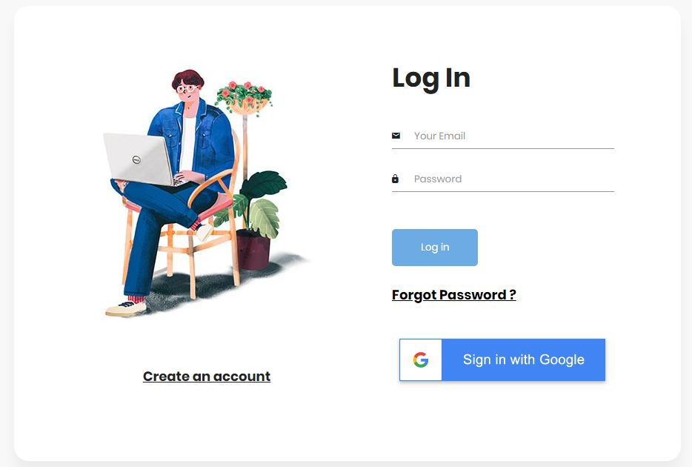

**Figure 5.1:** user login page

**User Registration page**

The snapshot shown in Figure 5.2 is the registration page for user.

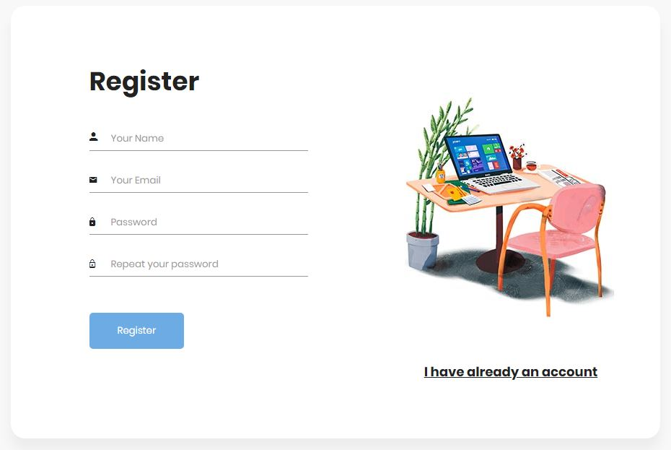

**Figure 5.2:** user registration page

**User Home page**

The snapshot shown in Figure 5.3 is the home page for user.

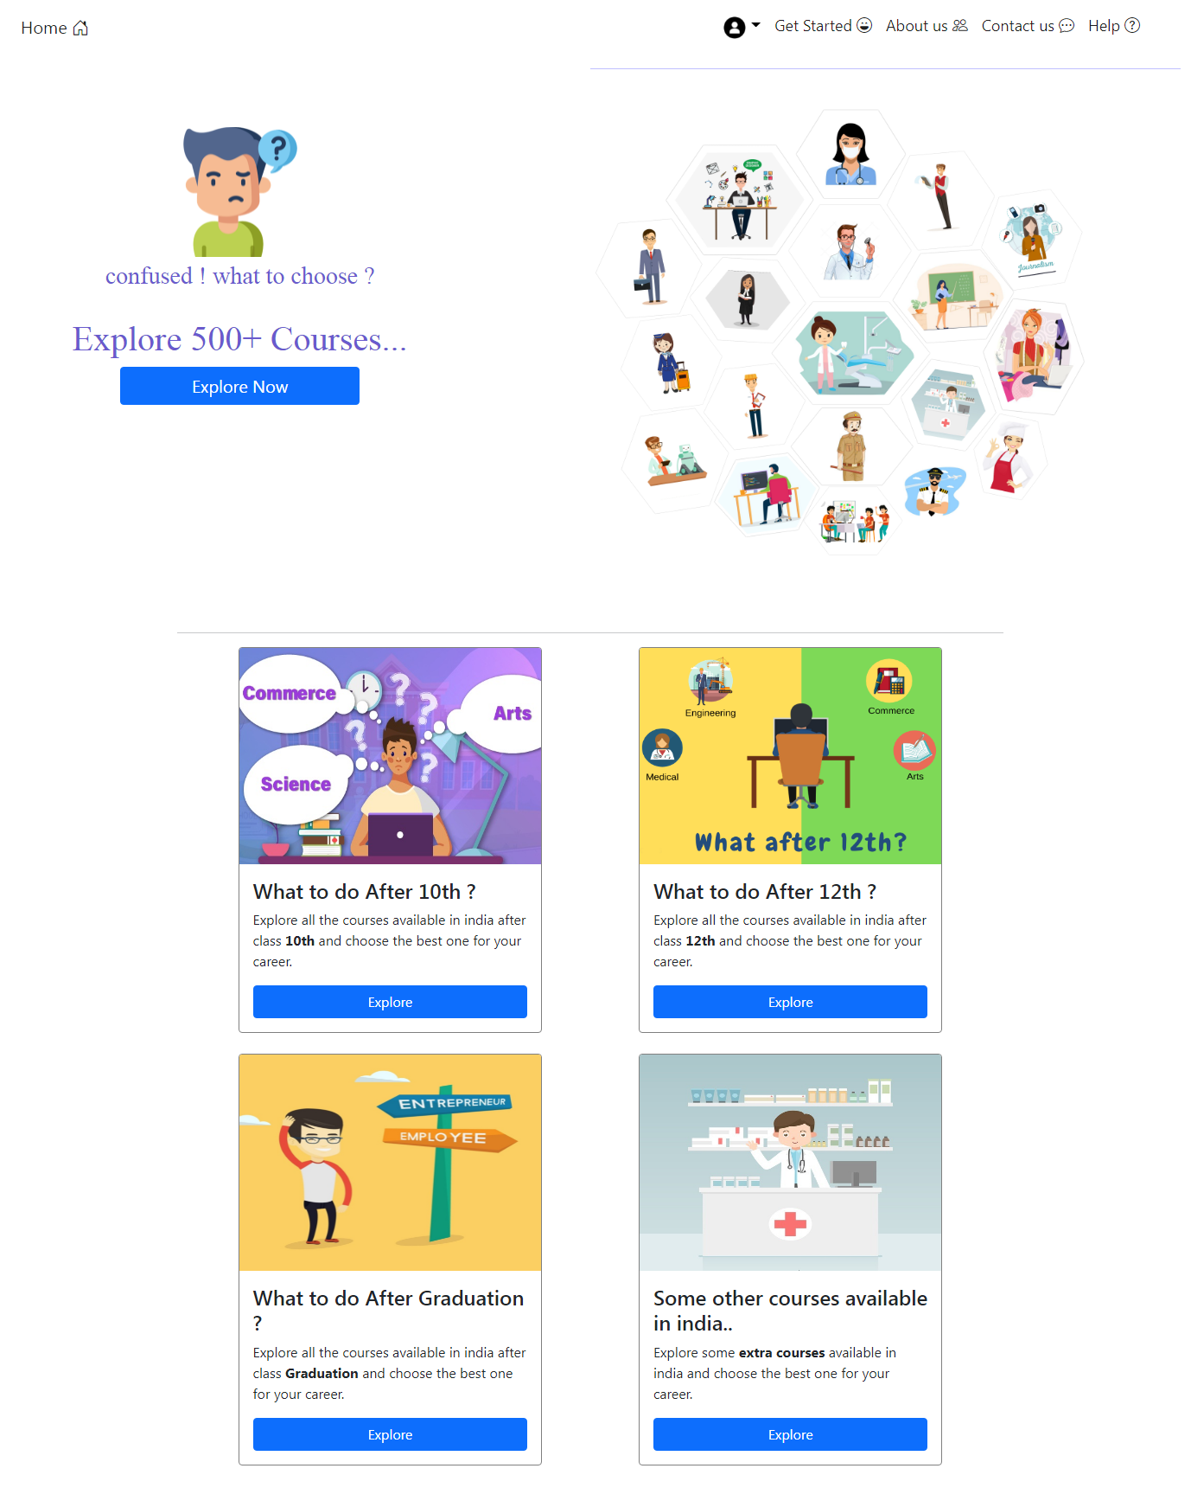

**Figure 5.3:** home page for user

**Page for courses after class 10th**

The snapshot shown in Figure 5.4 is the page where all the courses after class 10th are available.

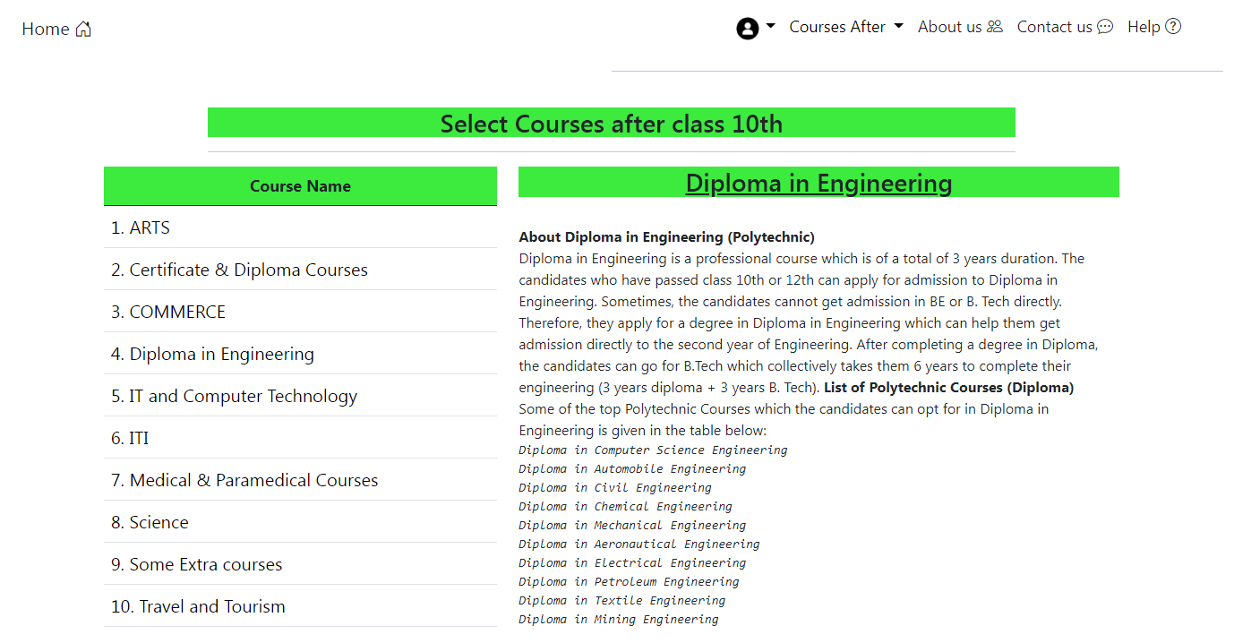

**Figure 5.4:** page for all the courses after class 10th

**Page for courses after class 12th**

The snapshot shown in Figure 5.5 is the page where all the courses after class 12th are available.

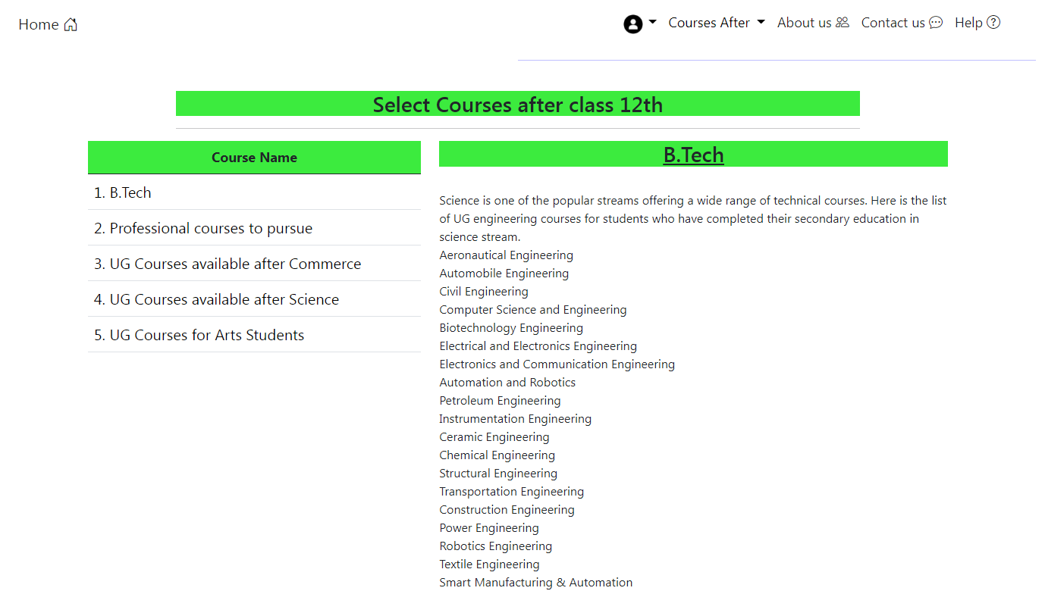

**Figure 5.5:** page for all the courses after class 12th

**Page for courses after Graduation**

The snapshot shown in Figure 5.6 is the page where all the courses after Graduation are available.

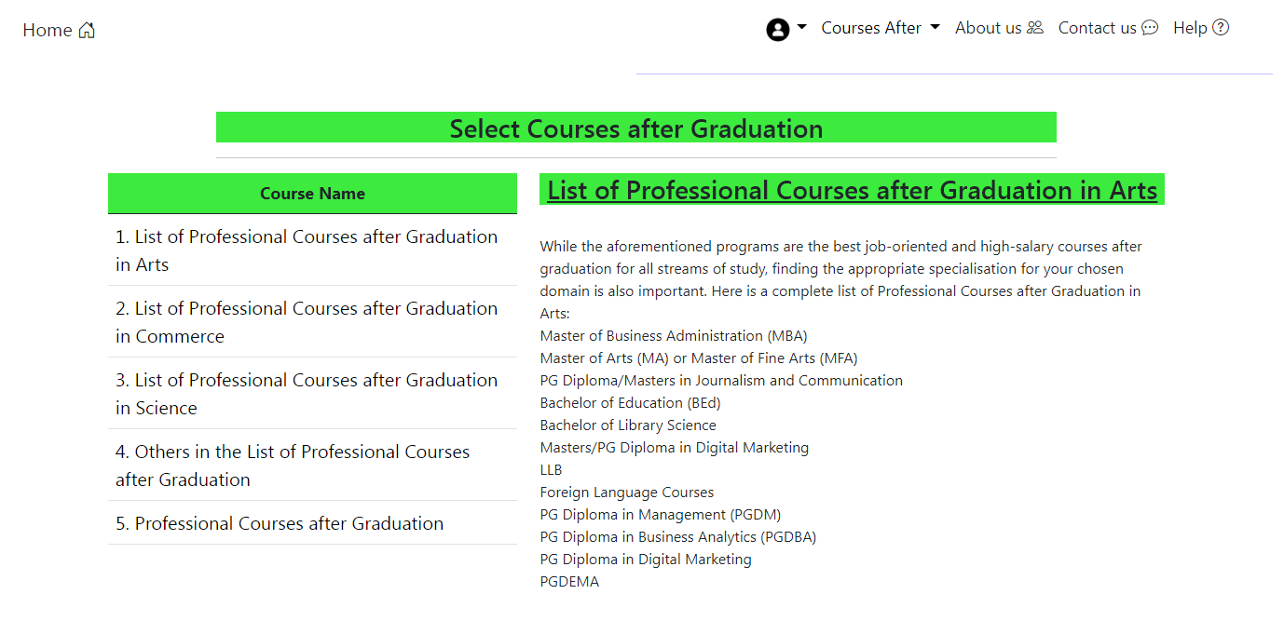

**Figure 5.6:** page for all the courses after Graduation

**Page for some extra courses**

The snapshot shown in Figure 5.7 is the page where some extra courses are available.

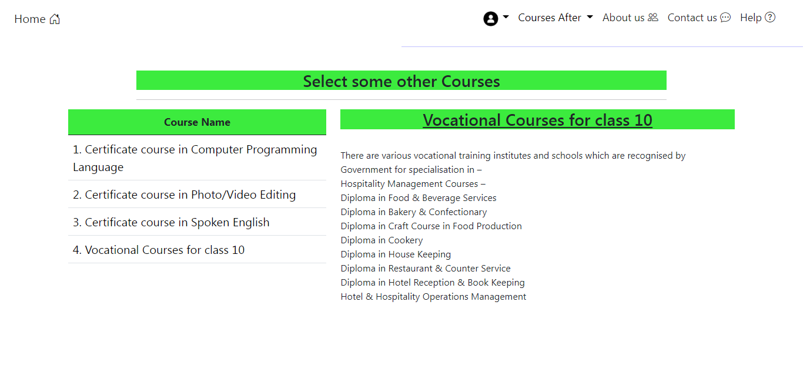

**Figure 5.7:** page for some extra courses

**Page Feedback**

The snapshot shown in Figure 5.8 is the page where user can send feedback to the admin.

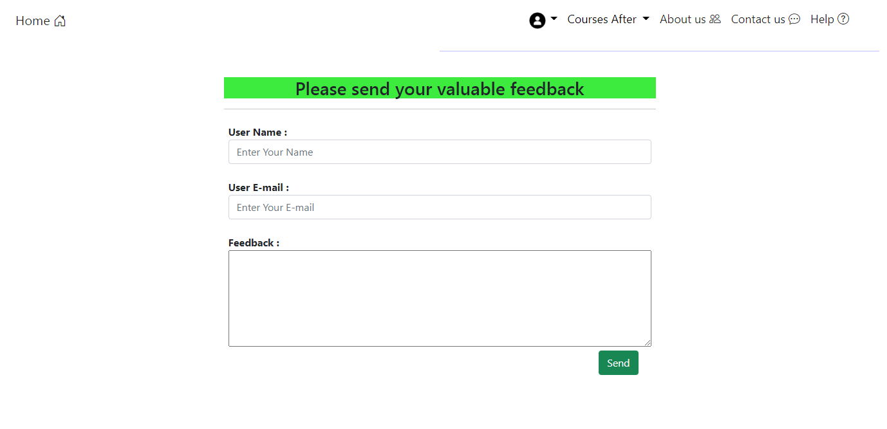

**Figure 5.8:** page for feedback

**Admin Login Page**

The snapshot shown in Figure 5.9 is the admin login page.

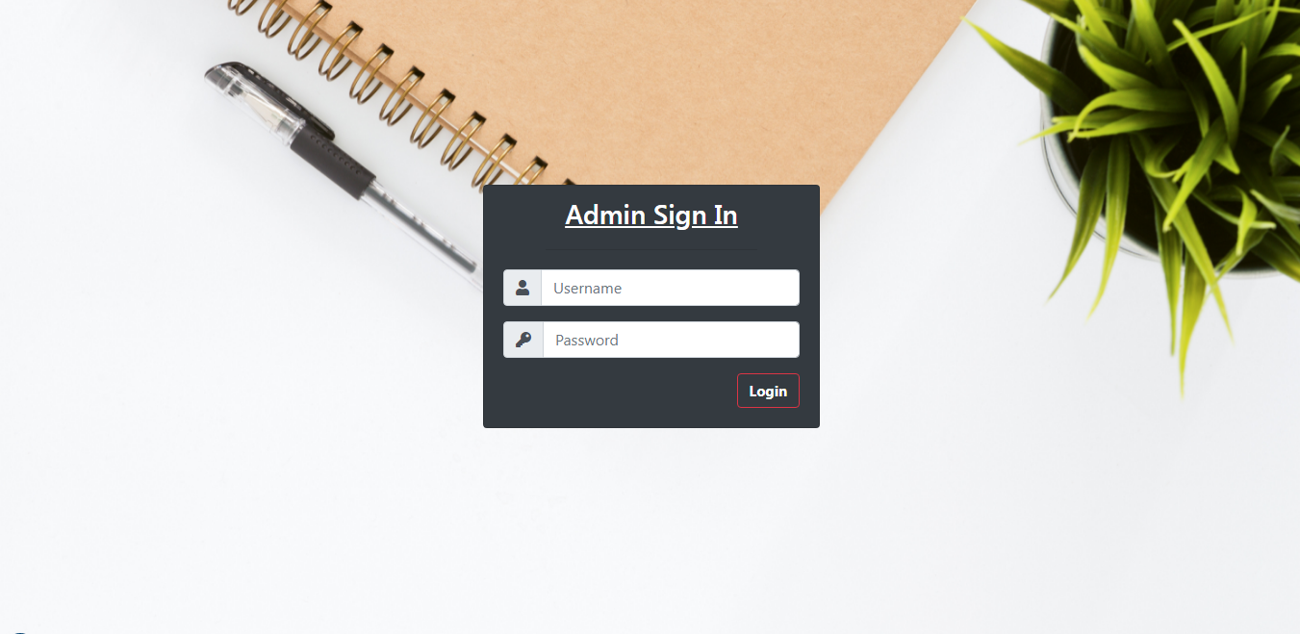

**Figure 5.9:** Admin login page

**Admin Dashboard page**

The snapshot shown in Figure 5.10 is the admin dashboard page, where admin can check some data like total numbers of courses, users etc.

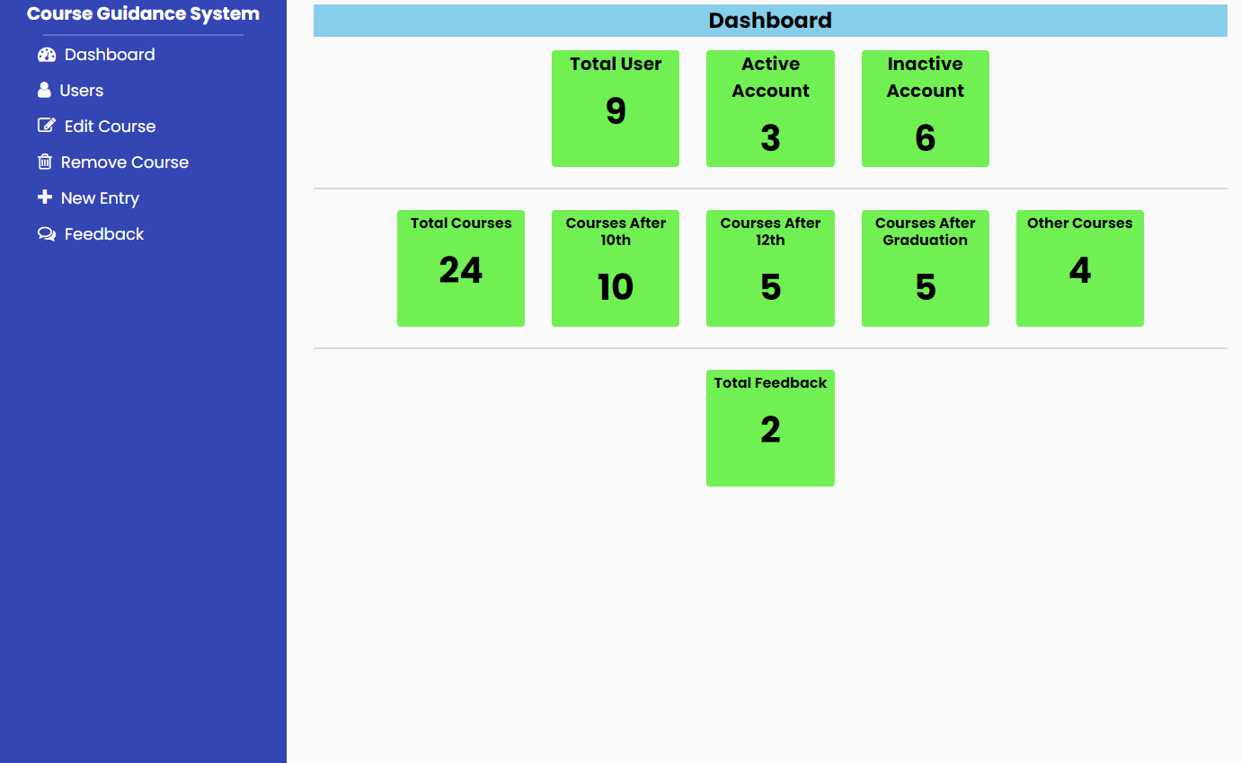

**Figure 5.10:** Admin dashboard page

**Users Manage page**

The snapshot shown in Figure 5.11 is the user manage page where admin can check all the users and also can remove the users.

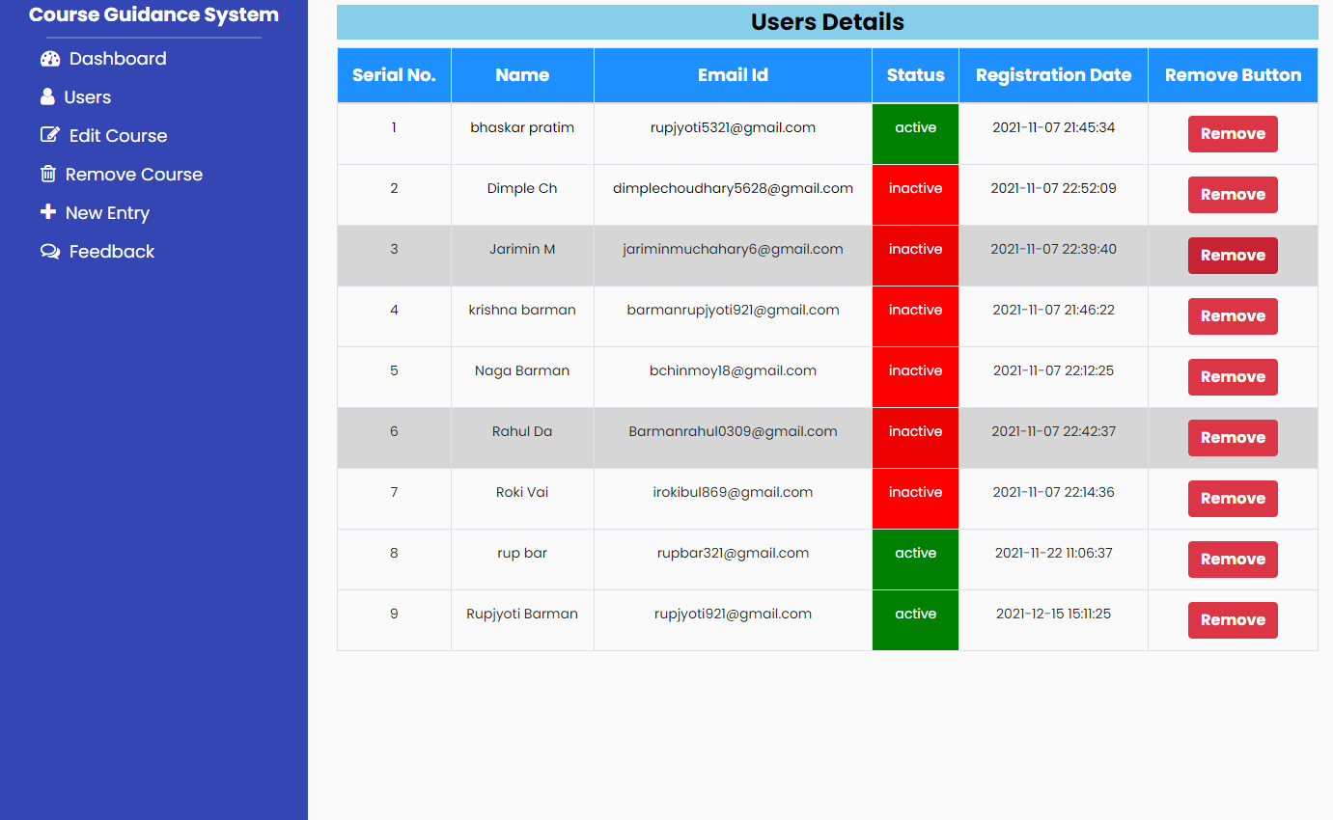

**Figure 5.11:** user manage page

**Page for update course**

The snapshot shown in Figure 5.12 is the page where admin can update an existing course.

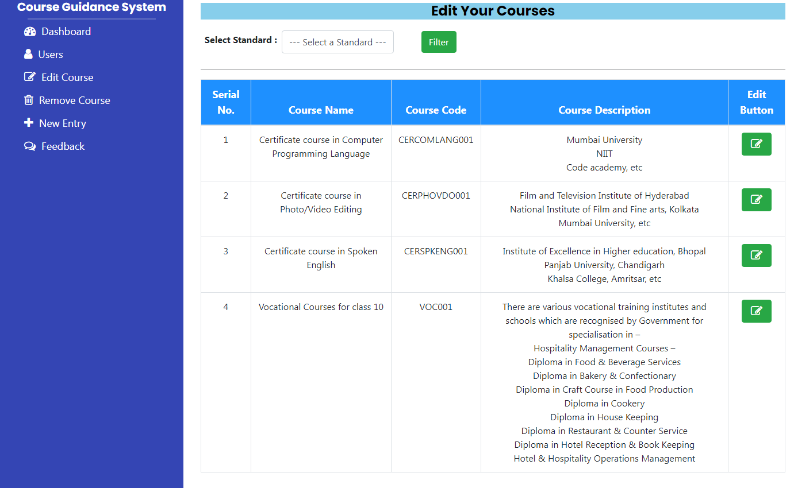

**Figure 5.12:** course update page

**Page for remove course**

The snapshot shown in Figure 5.13 is the page where admin can remove an existing course.

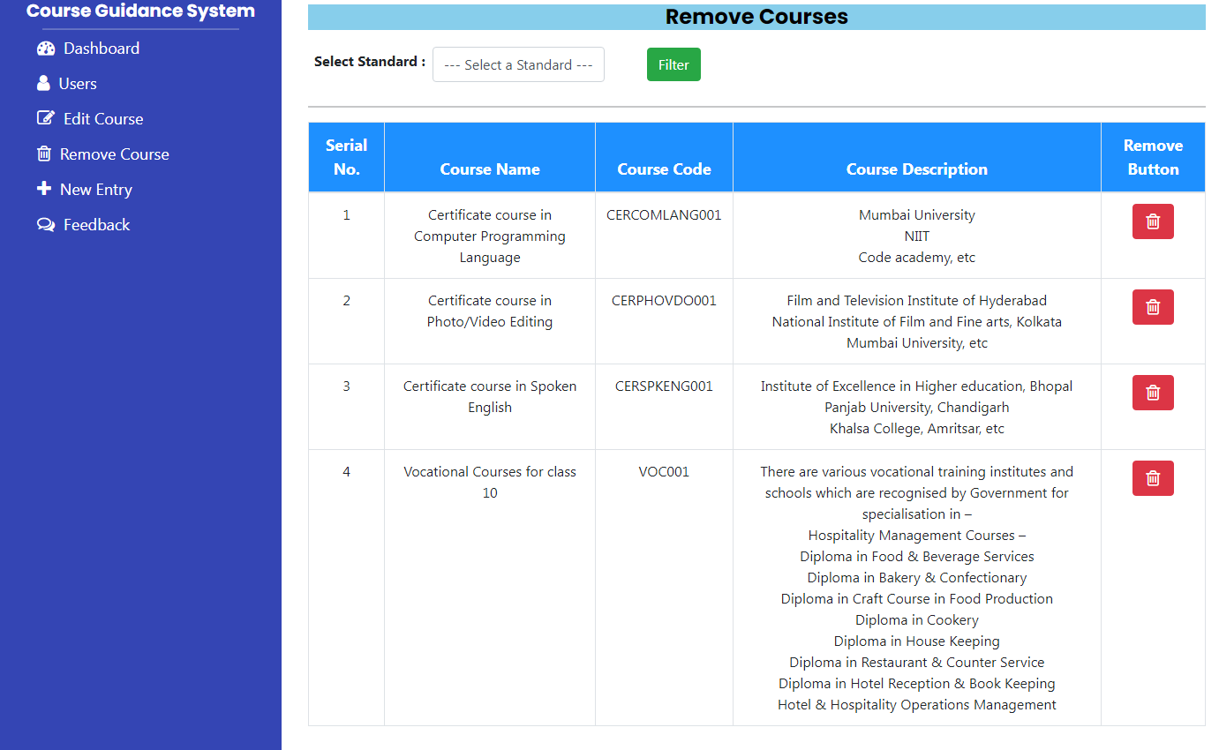

**Figure 5.13:** course remove page

**Page for New Entry of courses**

The snapshot shown in Figure 5.14 is the page where admin can add new courses.

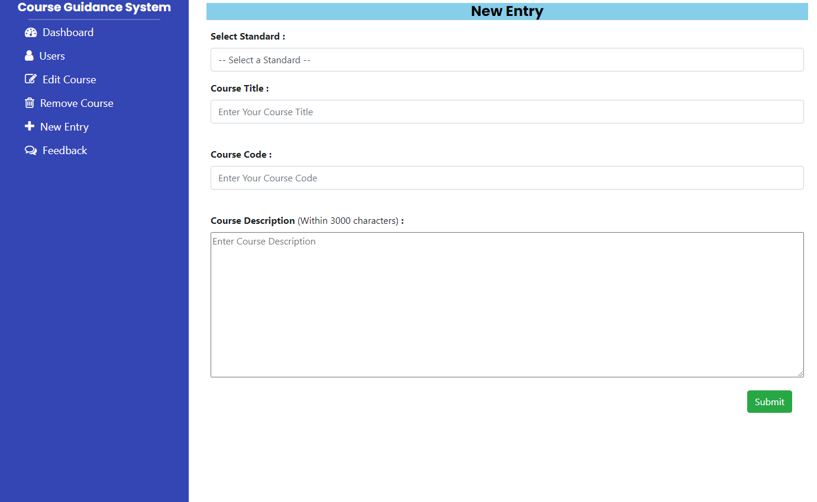

**Figure 5.14:** course entry page

**Page for read user feedback**

The snapshot shown in Figure 5.15 is the page where admin can read user feedback.

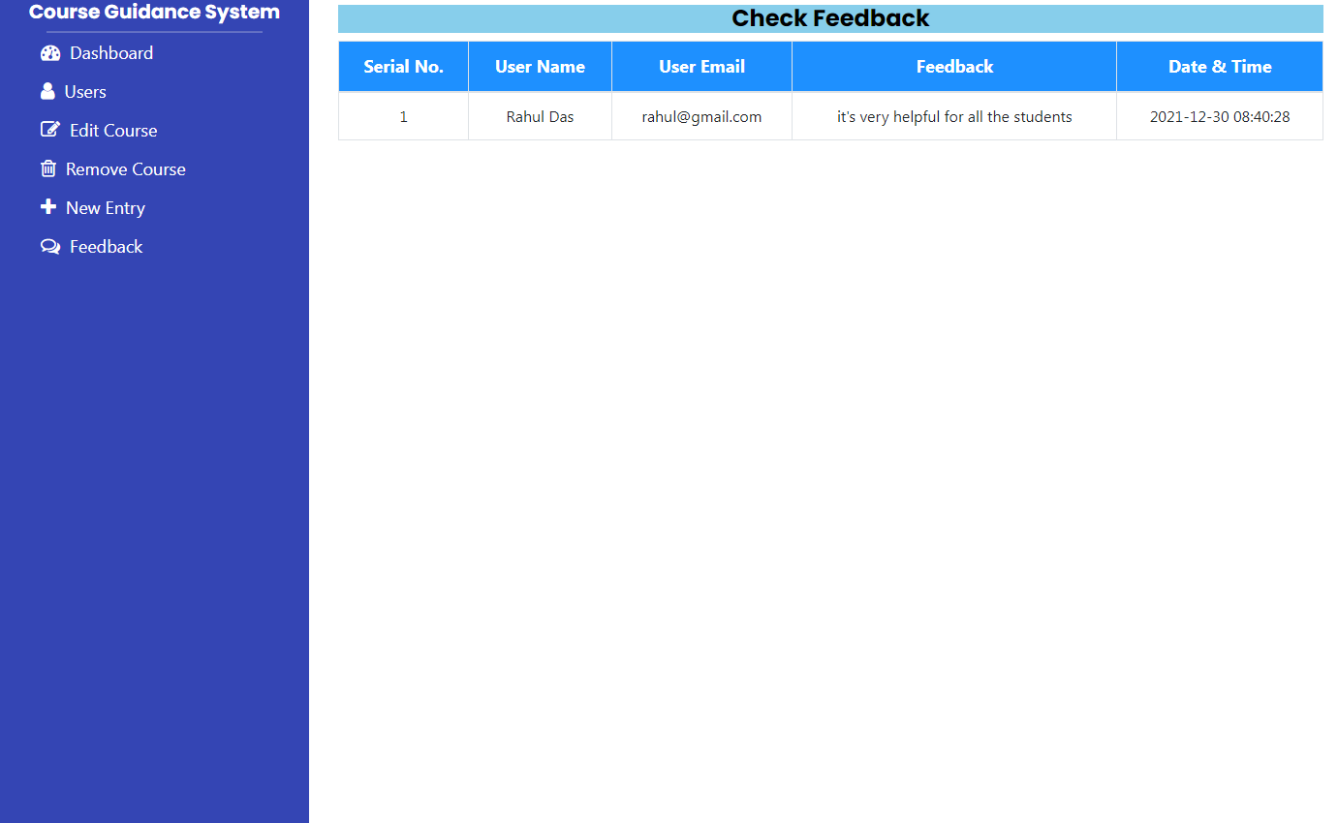

**Figure 5.15:** feedback page for admin

**CHAPTER-6**

**CONCLUSION AND FUTURE WORK**

**6.1 Conclusion and Future Work**

“Course Guidance System” is a web-based system. The main aim of the project is to guide students for the best career and courses. The system will help to explore different career and different courses.

In the present time, there are many students who belong to very backward area or village, who don’t have any mentor or guide and don’t know what to study after 10th, 12th or Graduation. Many students take wrong courses, because lack of knowledge and they regret in future. This system will help everyone to choose a best course.

The system will help students in many field in future. The updated version of the system will include many feature so the system can help in different filed and after getting the feedback from the user through feedback feature, system will improve its function and features.